**CUTRIC BURLINGTON PROTOTYPE**

OCAD University Visual Analytics Lab

Sara Diamond, Jeremy Bowes, Mona Ghafouri-Azar, Grace Yuan

# Introduction

The *CUTRIC Transit Fleet Electrification Analysis – Burlington* prototype is a dynamic HTML dashboard visualization environment that supports all the analytics that CUTRIC undertook and even extends these. It provides a GIS map (Cartographic) interface and related graphs/charts. We use the city of Burlington as the use case to develop the porotype. However, the prototype should serve as a template that can be applied to any other CUTRIC cities.

Based on CUTRIC’s request, all the tools we used are open source and free to use. We decided to use Mapbox(<https://www.mapbox.com/>) for all the on-map visualization. For graphs and charts, we use the JavaScript library D3.js(<https://d3js.org/>) and Observable notebooks(<https://observablehq.com/>), which comes with powerful resources for various types of data visualizations. The outcomes are a series of HTML web pages that can be hosted on CUTRIC’s servers.

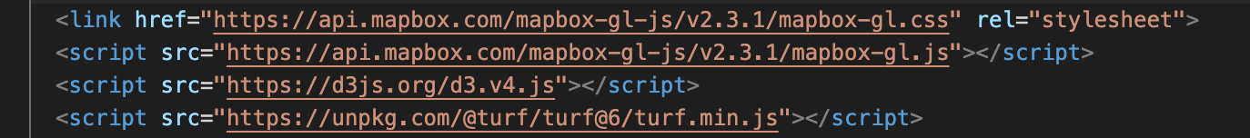

Figure - Main libraries used for the prototype

Table of Contents

Introduction 1

Page Structure 4

1. Landing Page/Cities 4

2. Simulation Results 6

3. Charging Results 12

4. GHG Emission Analysis 14

5. Electricity Cost Estimation 17

6. About 18

7. Contact Us 19

Code Components 20

Mapbox 20

D3.JS 21

Assets 22

Table of Figures

Figure 1 - Main libraries used for the prototype 1

Figure 2 - The Landing page: A national map with all the CUTRIC cities 5

Figure 3 - The Landing page: Zoomed-in view of the city of Burlington 5

Figure 4 - Main codes for the city listing functions 6

Figure 5 - Customize the link under Feature Properties 6

Figure 6 - The Simulation Results page 7

Figure 7 - Drop down menu 7

Figure 8 - Drop down menu and graphs inside 8

Figure 9 - Figure 9 in the Burlington report 9

Figure 10 - Range Analysis – Weekday 9

Figure 11 - Range Analysis – Saturday and Sunday 9

Figure 12 - Figure 5 in the Burlington report 10

Figure 13 - Success rate of one-to-one replacement of diesel buses with BEBs 10

Figure 14 - Interaction between the graph and the map 11

Figure 15 – The bus animation function 12

Figure 16 - The Charging Results Page 13

Figure 17 - The recovery time for Saturday vehicles graph 14

Figure 18 - The energy consumption graph 15

Figure 19 - A comparison chart of 2019 total GHG Emissions by diesel buses vs. BEBs 16

Figure 20 - Table 14 in the Burlington report 16

Figure 21 - 2019 Diesel usage by diesel buses at Burlington Transit 17

Figure 22 - Table 15 in the Burlington report 17

Figure 23 - Annual GHG emissions from electricity 18

Figure 24 - Figure 28 from the Burlington report 18

Figure 25 - Monthly cost comparison between diesel buses and BEBs 19

Figure 26 - Icon set 19

Figure 27 - The About page 20

Figure 28 - The Contact page 20

Figure 29 - Mapbox libraries 21

Figure 30 - Add maps to HTML 21

Figure 31 - Add any map related functions under map.on ('load', function(){}) 21

Figure 32 - How to embed a graph from Observable 22

Figure 33 - Fork the notebook to start editing 23

Figure 34 - Replace the data 23

Figure 35 - Asset overview 24

# Page Structure

The Nav Menu consists of 7 items:

1. Cities

Also known as the landing page. This page will host a national map with all the CUTRIC cities for the user to choose from. User can always go back to the landing page to explore a different city.

2. Simulation Results

This page will host all the on-map visualizations with simulation results for range analysis.

3. Charging Results

This page will host all the standalone graphs related to charging, recovery time, and energy consumption by charging.

4. GHG Emissions Analysis

This page will host any standalone graphs related to the GHG emission analysis.

5. Electricity Cost Estimation

This page will host any standalone graphs related to the transit cost.

6. About

This is where CUTRIC could include any information about this project or the team.

7. Contact

This page will host any contact information.

## 1. Landing Page/Cities

The prototype begins with a landing page to help the user navigate. On the page there is a map with a list of city names for user to browse all the CUTRIC cities on the national level. Users can select one city to review, by choosing the city’s name either on the side bar or on the map directly.

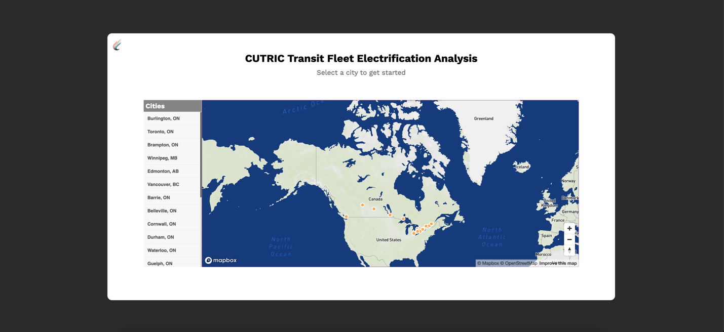

Figure - The Landing page: A national map with all the CUTRIC cities

Originally centred around Canada, the map will fly to and zoom in between different cities based on the user’s selection. Once the user selects a city, the map flies to the city’s location and zoom in to the city’s level. An orange ‘Enter’ button shows up and when the user hover over it, the city’s name pops up in the tooltip. After confirming the city that they want to continue with and click on the ‘Enter’ button, the user will be taken to another webpage where they can find all the analytics and visualizations of that city. Each city will be hosted on a separate site/dashboard, for the ease of data organization and user navigation. For this prototype, only Burlington has a functional link.

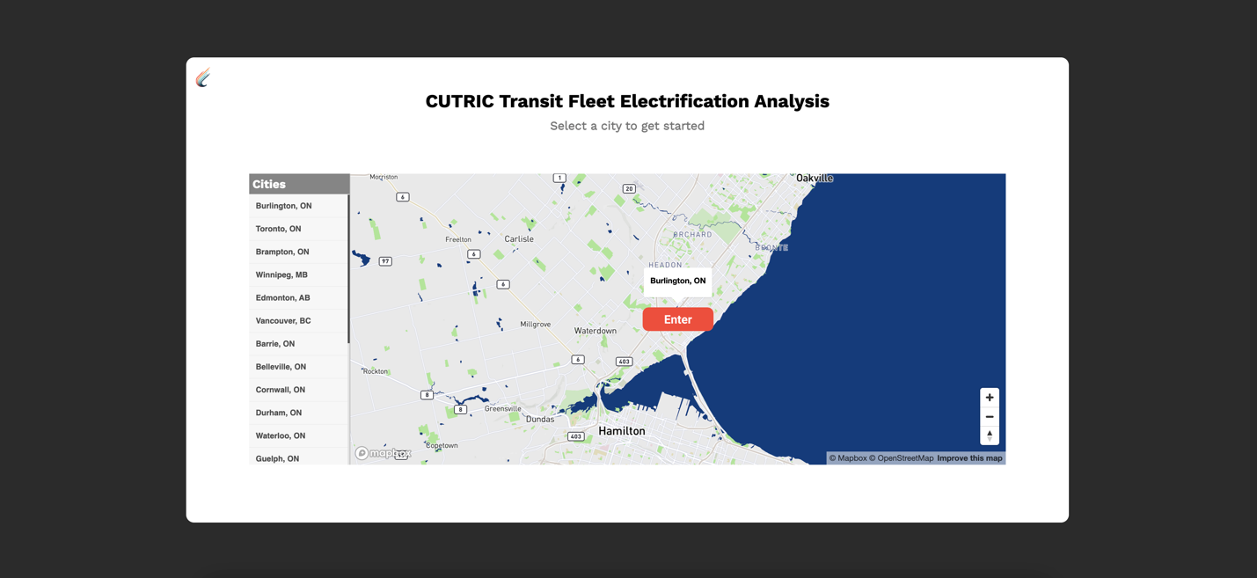

Figure - The Landing page: Zoomed-in view of the city of Burlington

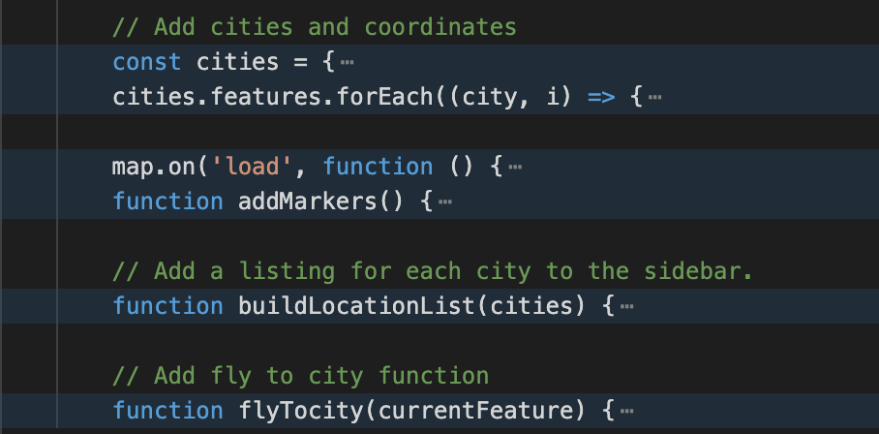

Figure - Main codes for the city listing functions

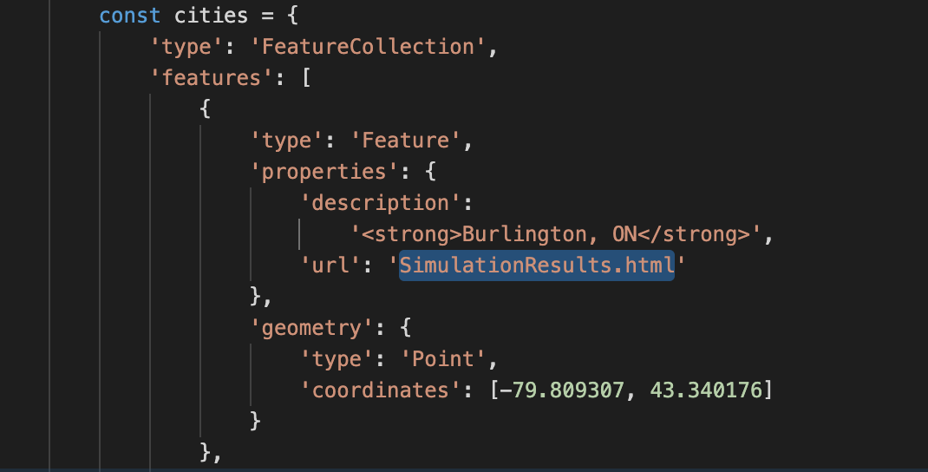

Figure - Customize the link under Feature Properties

## 2. Simulation Results

All the map-related visualizations will live on this page. The top half of the screen consists of two maps for comparing two types of electric bus: the map on the left visualizes Bus #1(Battery 400+ kWh, Weight ~15,000 kg), and the map on the right visualizes Bus #2(Battery 600+ kWh, Weight ~ 15,000 kg). The movement between two maps are in sync. Basic map navigation controls are added to the map, including geocoder search bar, zoom in/zoom out, and reset bearing to north. On the left side of each map there are menus to toggle on and off map layers, including: 1) contours; 2) hillshade; 3) all the bus routes in Burlington; 4) all the bus stops.



On the map, user can find the legends for all the potential electric bus charger locations with pop-up details on hover.



On the right bottom corner of each map, there are two icons that will each take the user to the GHG Emissions Analysis page and the Electricity Cost Estimation page.

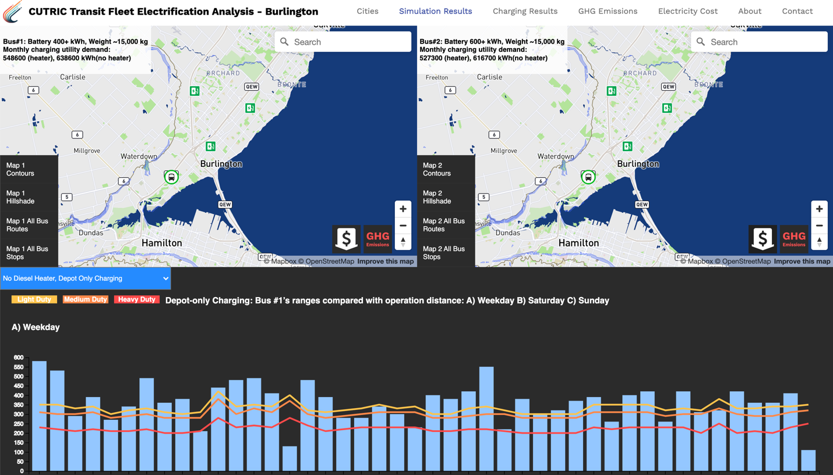

Figure - The Simulation Results page

At the bottom half of the page, there is a drop-down menu to select between four sets of graphs: 1) No Diesel Heater, Depot Only Charging; 2) Diesel Heater, Depot Only Charging; 3) No Diesel Heater, Opportunity Charging; 4) Diesel Heater, Opportunity Charging. Each set of graph contains Range Analysis graphs for weekdays, Saturday, and Sunday, categorized by bus #1 and bus #2; and success rate of one-to-one replacement of diesel buses with BEBs.

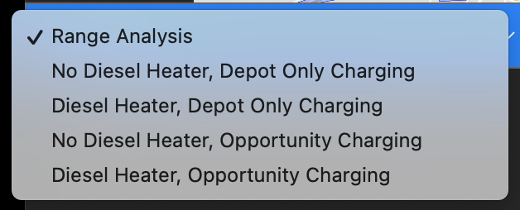

Figure - Drop down menu

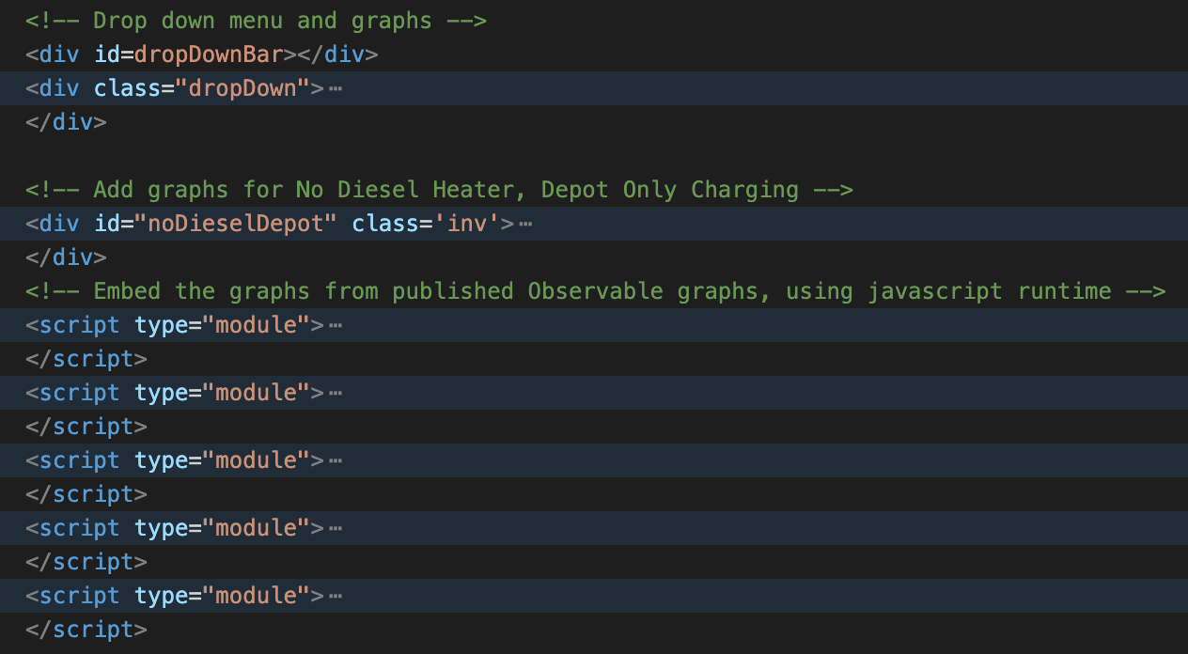

Figure - Drop down menu and graphs inside

The range analysis graphs are built upon the graphs in the CUTRIC Burlington report. The data was roughly extracted from the graphs with non-accurate numbers because we were not supplied with the raw data. Please note that only one set of the range analysis graph was created based on “Figure 9. Bus #1’s ranges after using diesel heater compared with operation distance: A) Weekday B) Saturdays C) Sundays” and “Figure 5. Success rate of one-to-one replacement of diesel buses with BEBs without a diesel heater (summer and winter are the same)” from the report. We used this set of graphs repetitively under all four dropdowns to show how several graphs can be displayed to cover all four situations. When hover over each blue bar, more details will be displayed on a tooltip.

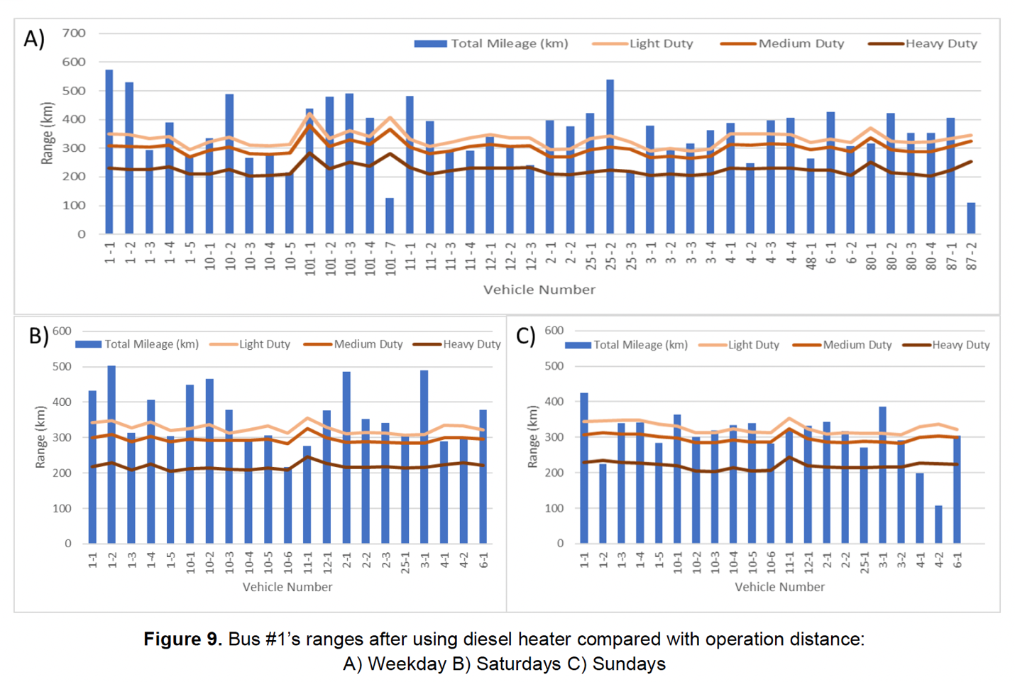

Figure - Figure 9 in the Burlington report

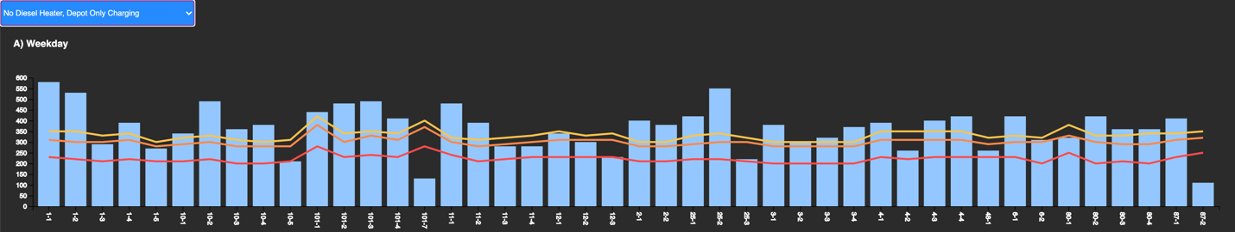

Figure - Range Analysis – Weekday

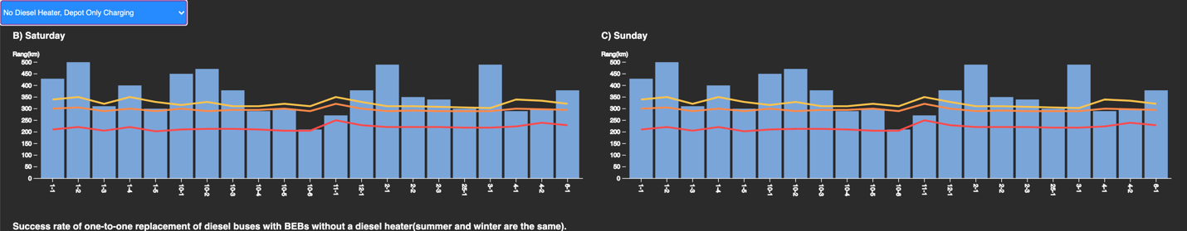

Figure - Range Analysis – Saturday and Sunday

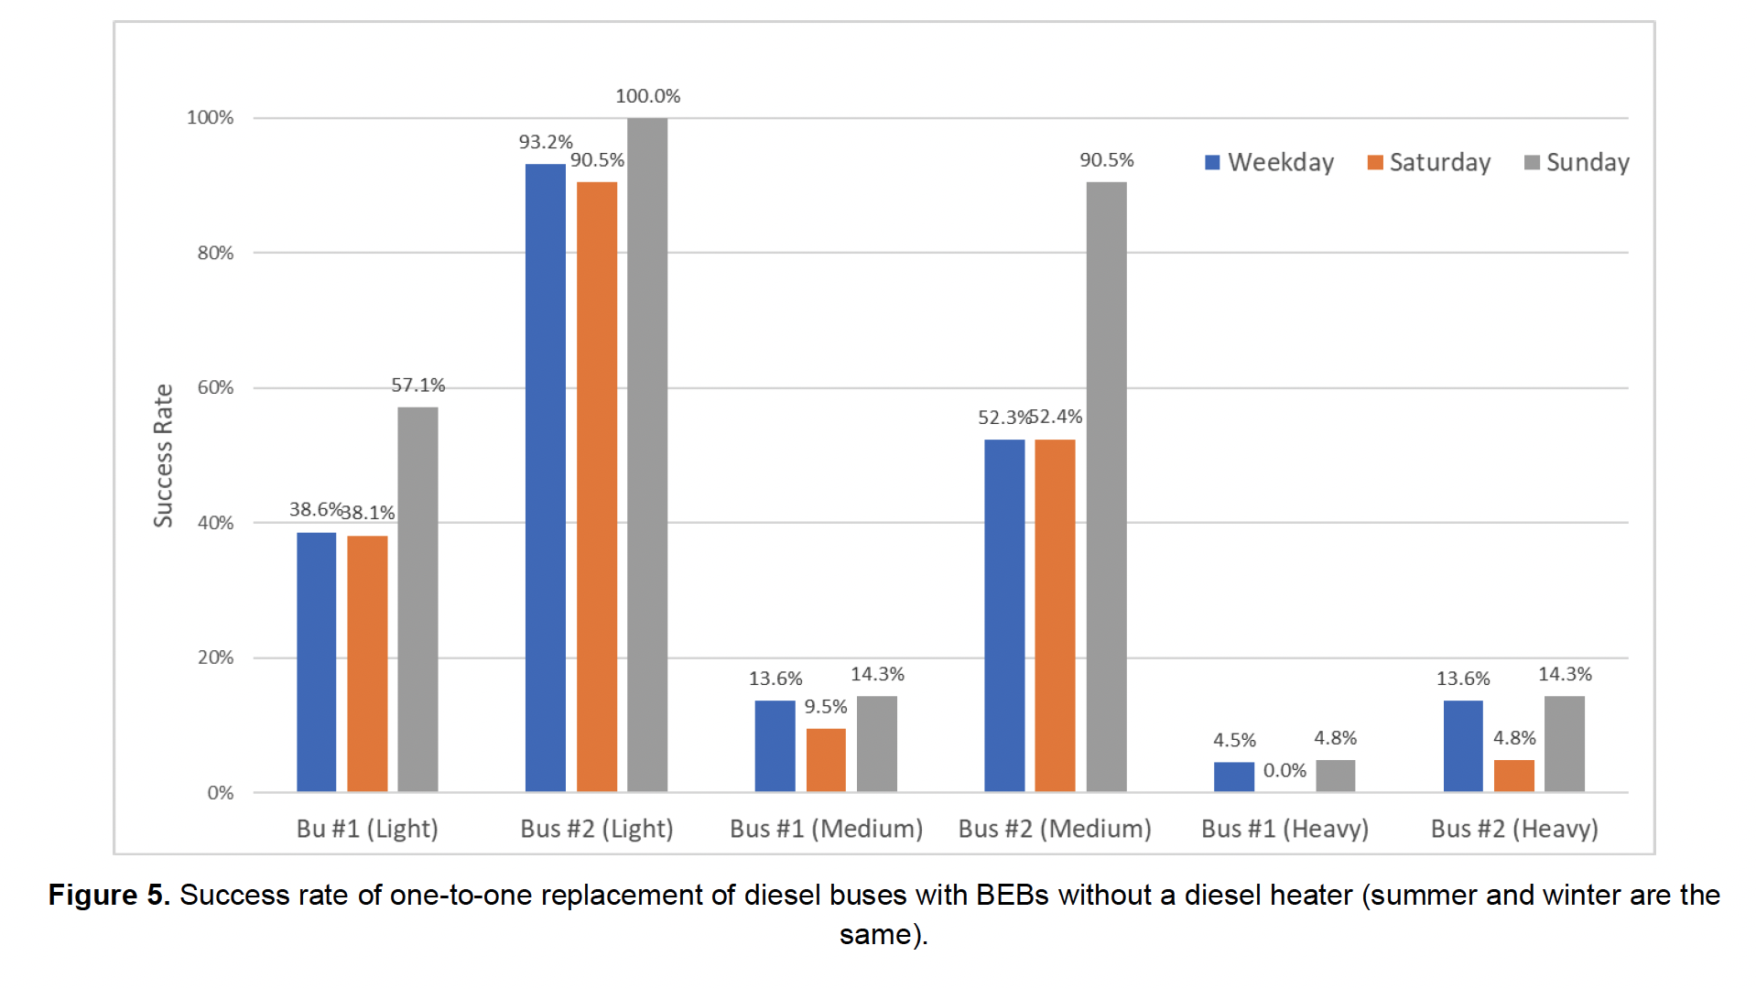

Figure 12 - Figure 5 in the Burlington report

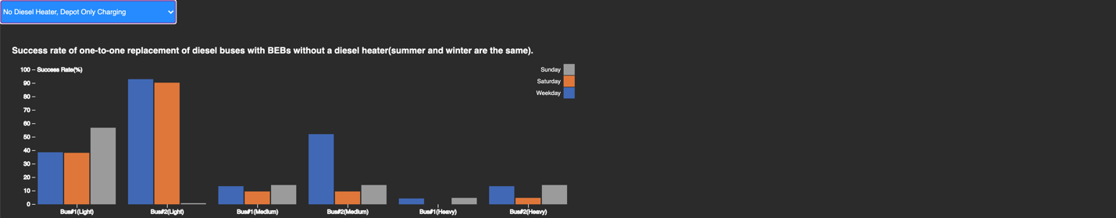

Figure - Success rate of one-to-one replacement of diesel buses with BEBs

We implemented the interaction between the graphs and the maps by animating the bus running on route. Bus 1 and Bus 2 on route 4 are selected to be prototyped with animation. When the user clicks on the 4-1 or 4-2 blue bar on the Bus #1 or Bus #2 Weekday graph under the second drop-down item “No Diesel Heater, Depot Only Charging”, the corresponding bus will start running on the map along the route. The outer circle of the bus icon has a potential to represent the battery status of the bus. Note that animation has only been implemented to those two graphs for 4-1 and 4-2 buses as a demonstration. The two graphs are added to the html directly with JavaScript codes instead of Observable JavaScript runtime import.

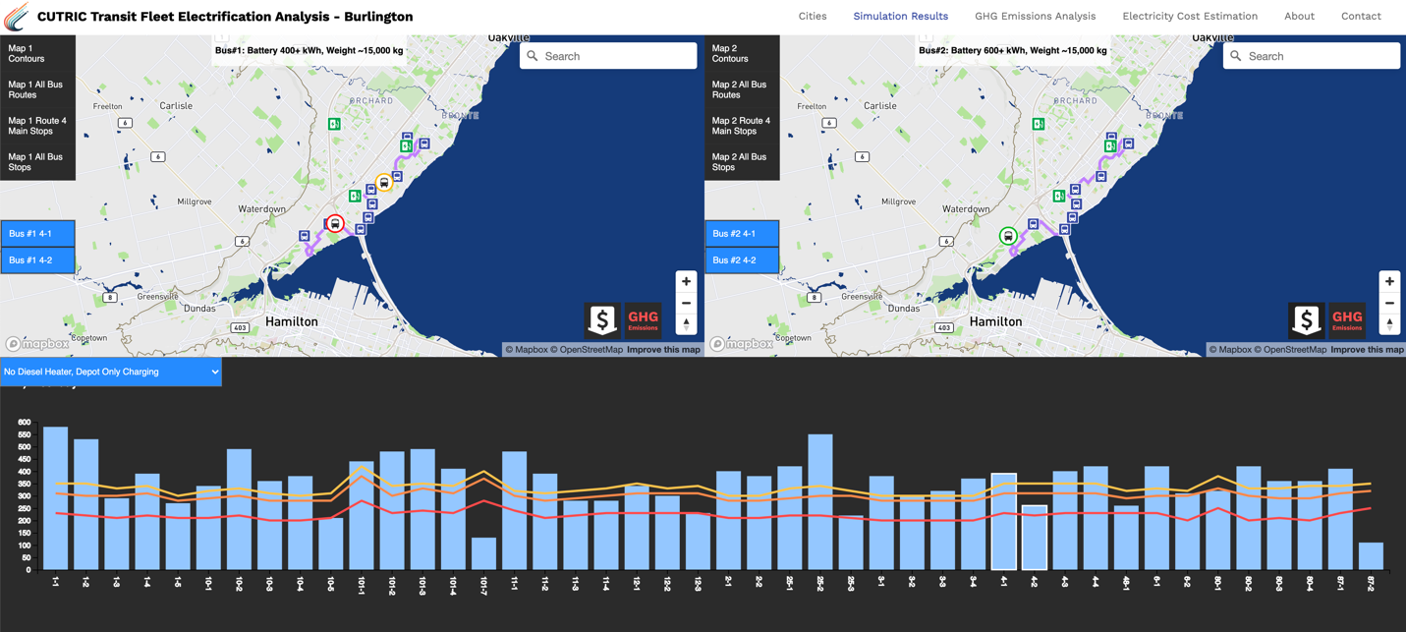

Figure - Interaction between the graph and the map

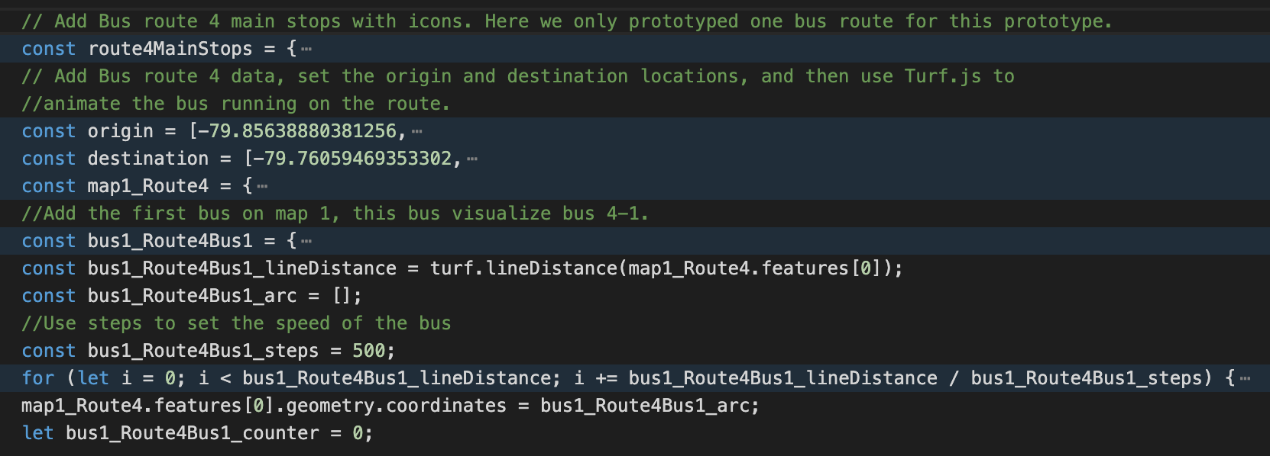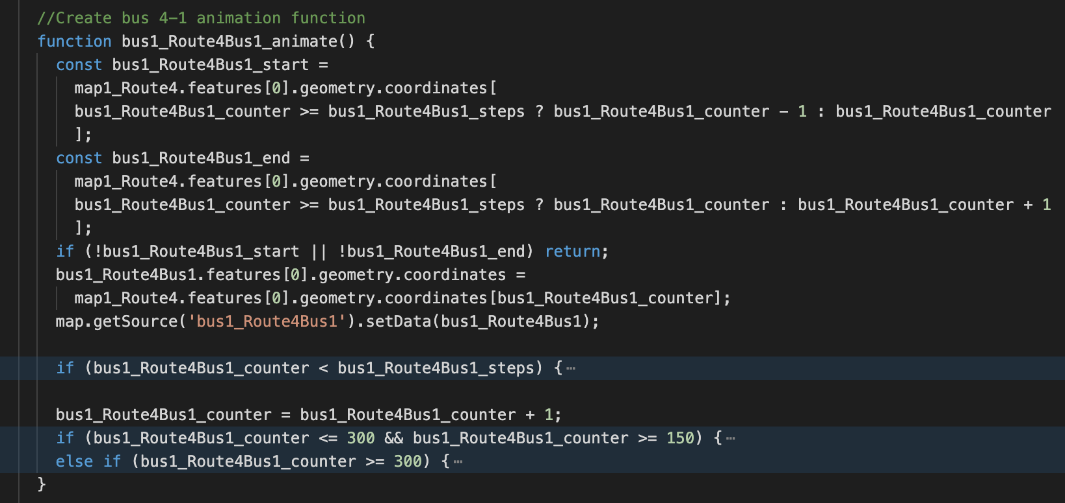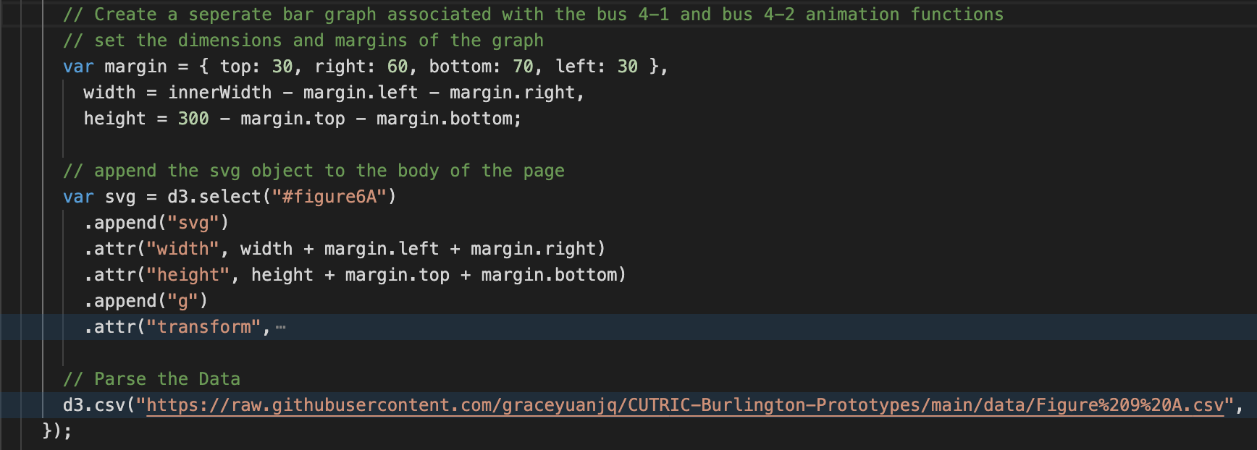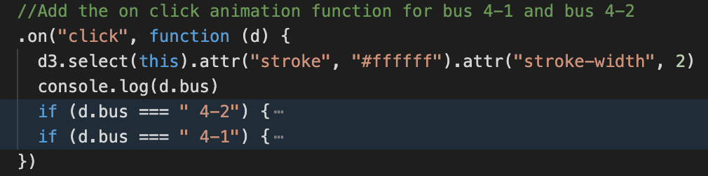

Figure – The bus animation function

## 3. Charging Results

On this page, the user will find 2 graphs related to the charging and energy consumption.

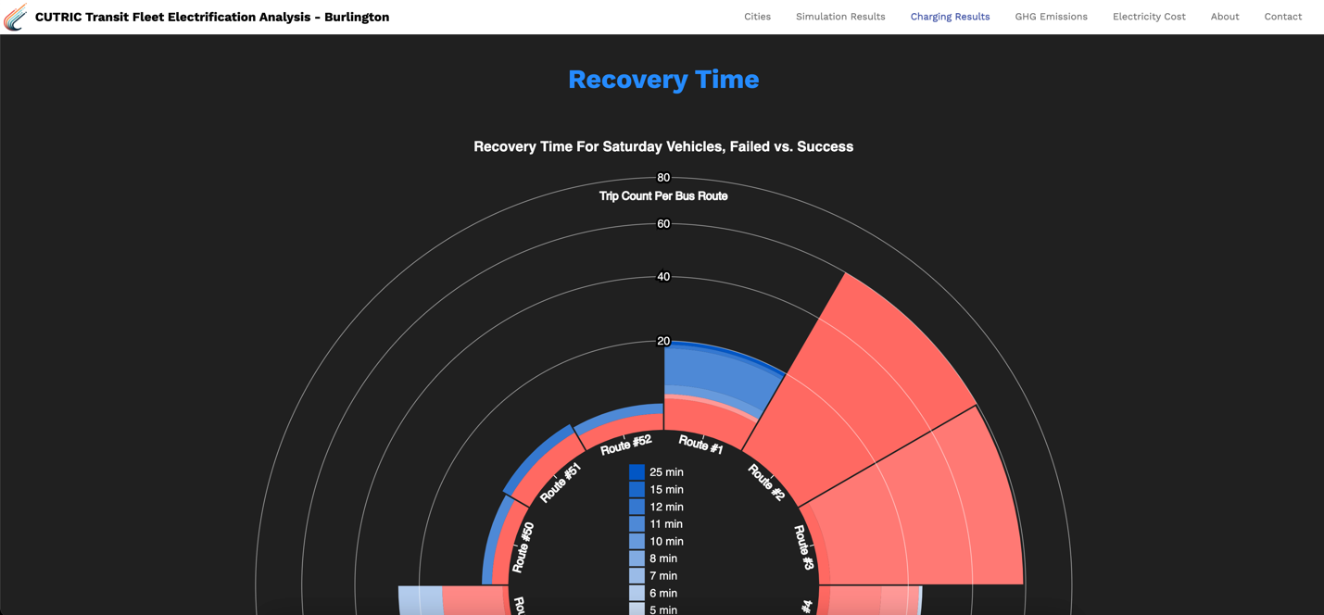

Figure - The Charging Results Page

The first graph represents the failed and success recovery time proportionally for Saturday vehicles, based on trip counts. The required recovery time for opportunity charging is 5 minutes, thus, any trip with less than 5 minutes recovery time fails. For future development, Weekday and Sunday vehicles should be visualized as well.

For this graph, the X-axis shows the route numbers, while the Y-axis shows the count of trips on each route with corresponding recovery time. It aims to show among all the routes, which ones are already suitable for opportunity charging verses the ones that are not on a high level. The red gradient colors refer to the trips that do not meet the 5 minutes requirement, and the blue gradient colors refer to the success trips.

We took the “BT_RecoveryTime_Saturday” data and sorted out the trip counts based on recovery time and generated the data set “Recovery time Saturday.csv” that is used to create this graph.

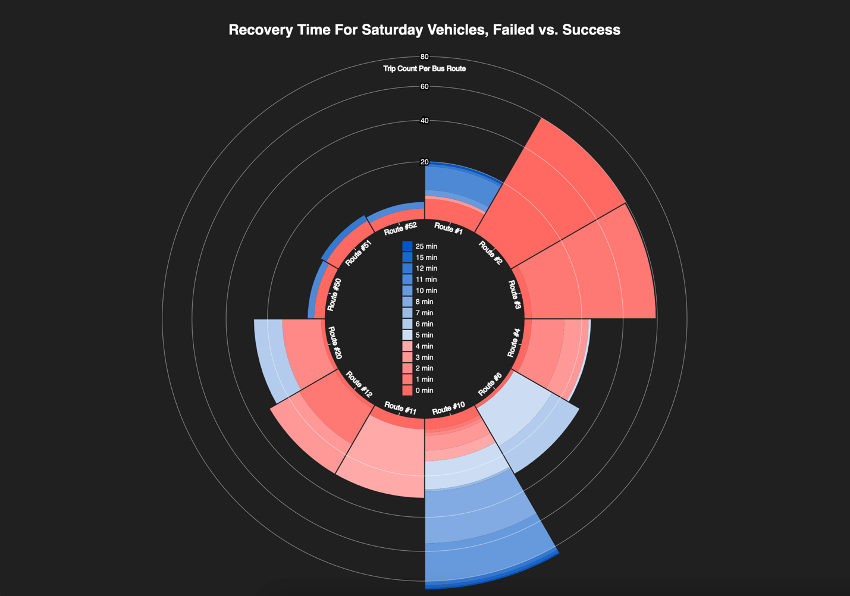

Figure - The recovery time for Saturday vehicles graph

The second graph on the Charging Results page shows the energy consumption of both depot charging and opportunity charging results, as they are the same. When hover over each bar, the detailed number will show up on the tooltip.

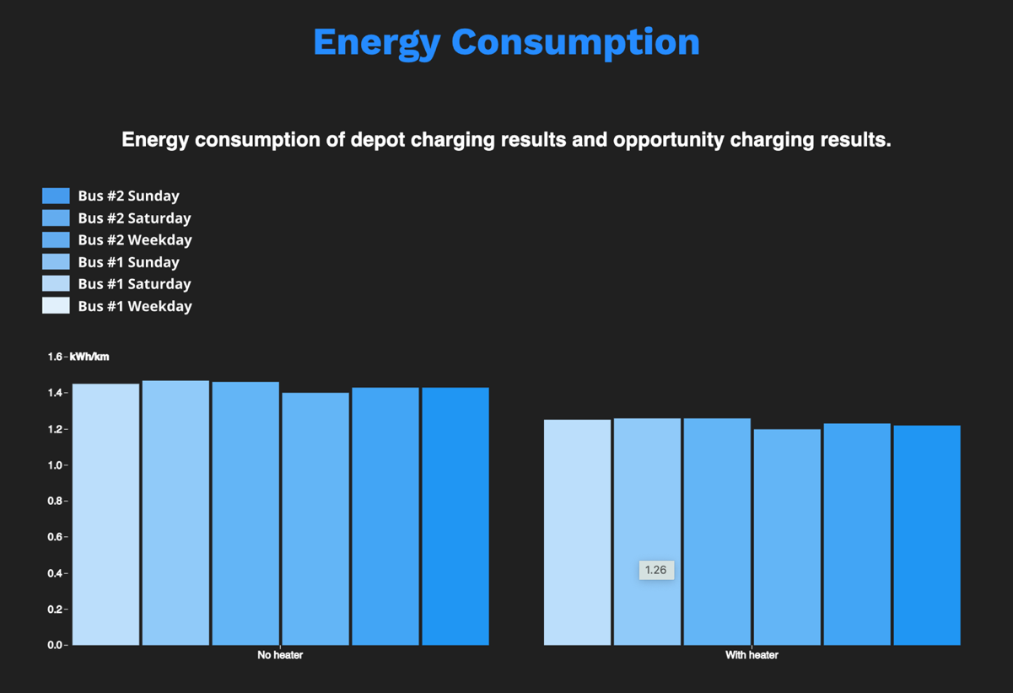

Figure - The energy consumption graph

## 4. GHG Emission Analysis

On this page, the user will find graphs that visualizes the GHG emission analysis for both diesel bus and electric bus.

The first graph is a comparison chart of 2019 total GHG Emissions by diesel buses vs. BEBs. It is animated to show how the GHG emissions accumulated monthly in 2019. The animation stops at the annual total GHG emissions generated in 2019, accumulated after 12 months. The red bars represent diesel bus verses the blue bars represent BEBs. The bus model name is attached at the right end of each bar. The month is shown at the bottom right.

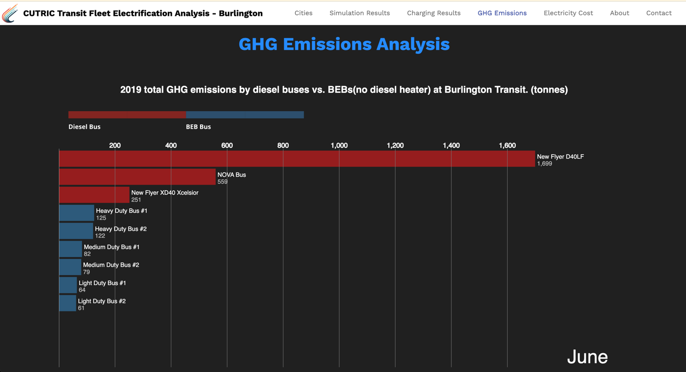

Figure - A comparison chart of 2019 total GHG Emissions by diesel buses vs. BEBs

The second graph is a line chart displaying 2019 diesel usage by diesel buses at Burlington Transit. The data was extracted from the Table 14 in the Burlington report.

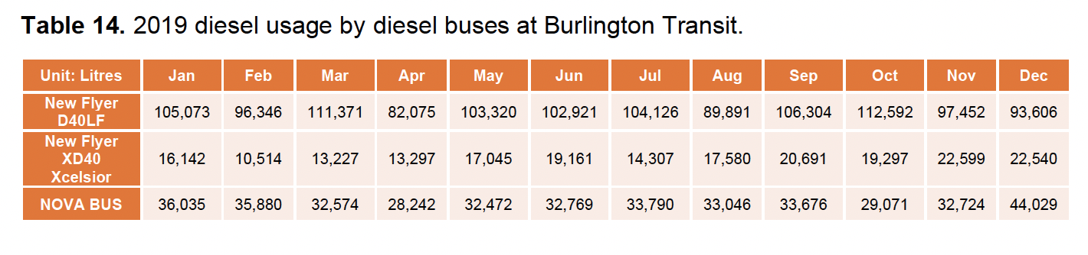

Figure - Table 14 in the Burlington report

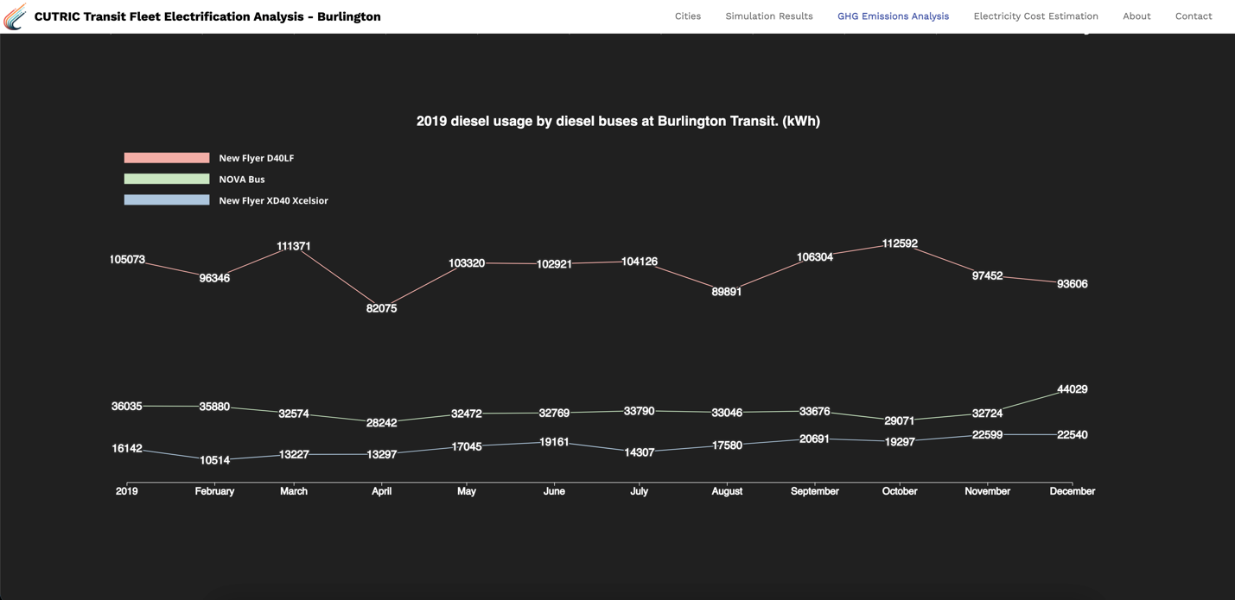

Figure - 2019 Diesel usage by diesel buses at Burlington Transit

The third graph is a grouped bar chart displaying annual GHG emissions from electricity, based on Table 15 in the Burlington report.

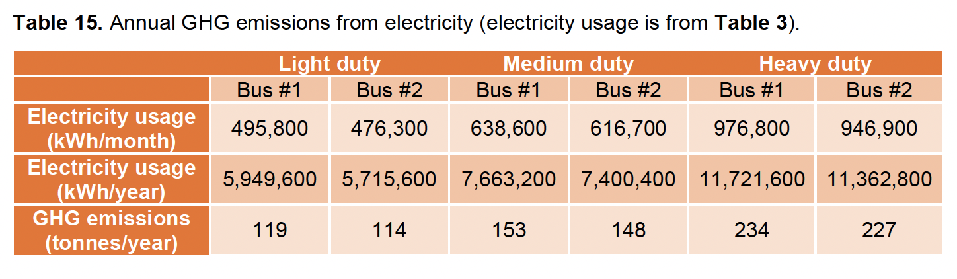

Figure - Table 15 in the Burlington report

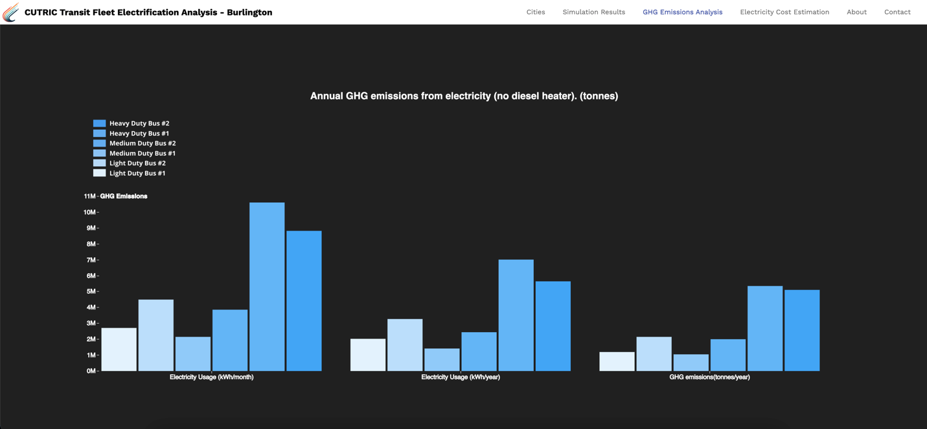

Figure - Annual GHG emissions from electricity

## 5. Electricity Cost Estimation

On the Electricity Cost Estimation page, the user will find graphs that visualizes electricity cost estimation for both diesel bus and electric bus.

The bar chart on display is based on Table 28 from the Burlington report.

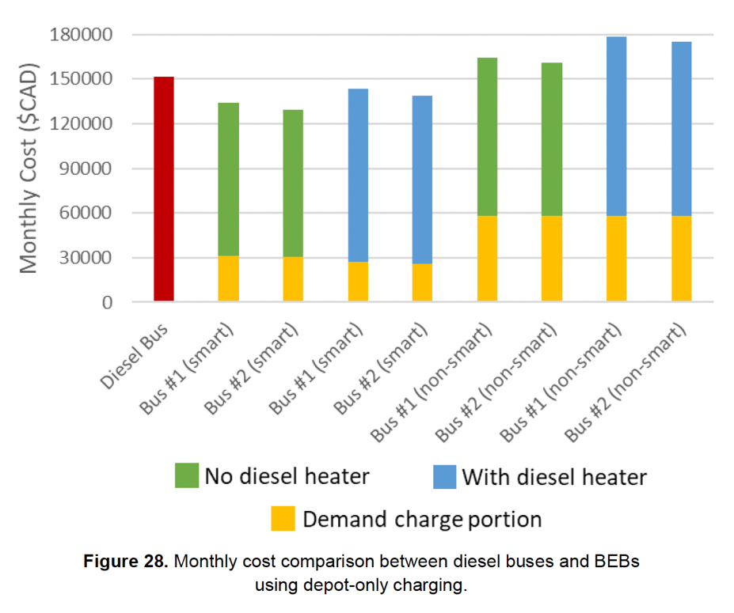

Figure - Figure 28 from the Burlington report

We developed a set of icons to represent the electric bus vs. diesel bus, smart bus vs. non-smart bus, with diesel heather vs. no diesel heater, bus #1 vs. bus #2. When hover over each bar, more details will be displayed on a tooltip.

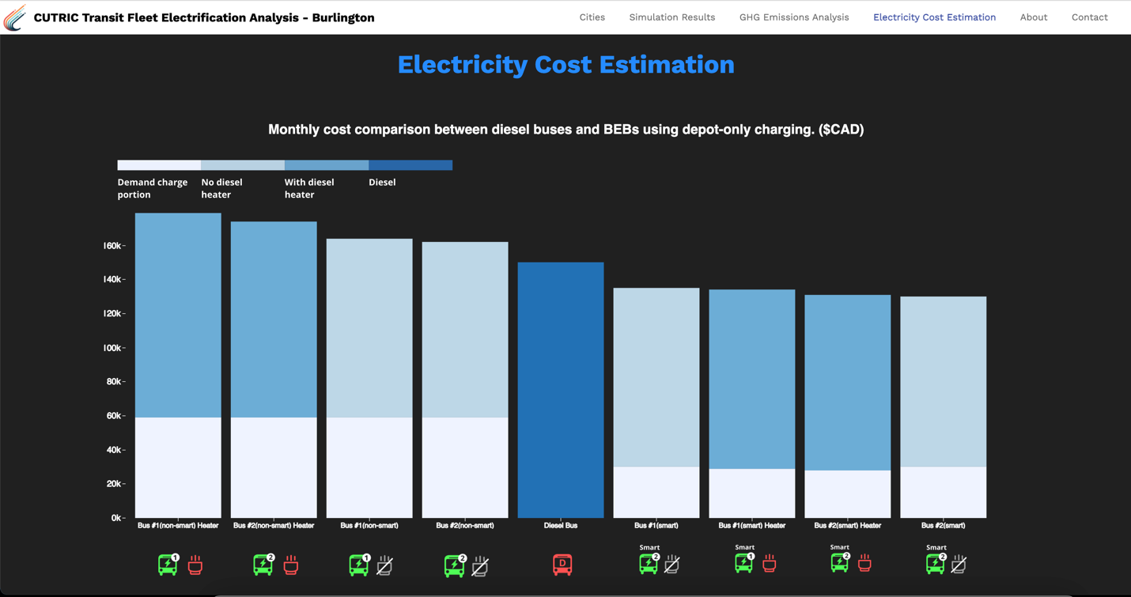

Figure - Monthly cost comparison between diesel buses and BEBs

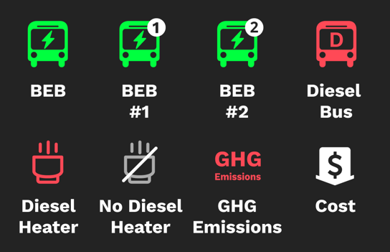

Figure - Icon set

## 6. About

The about page can contain any information CUTRIC would like to show related to the transit analysis or the team. For the prototype, we borrowed some descriptions and one group photo from CUTRIC’s official website, to indicate how this page can be potentially used.

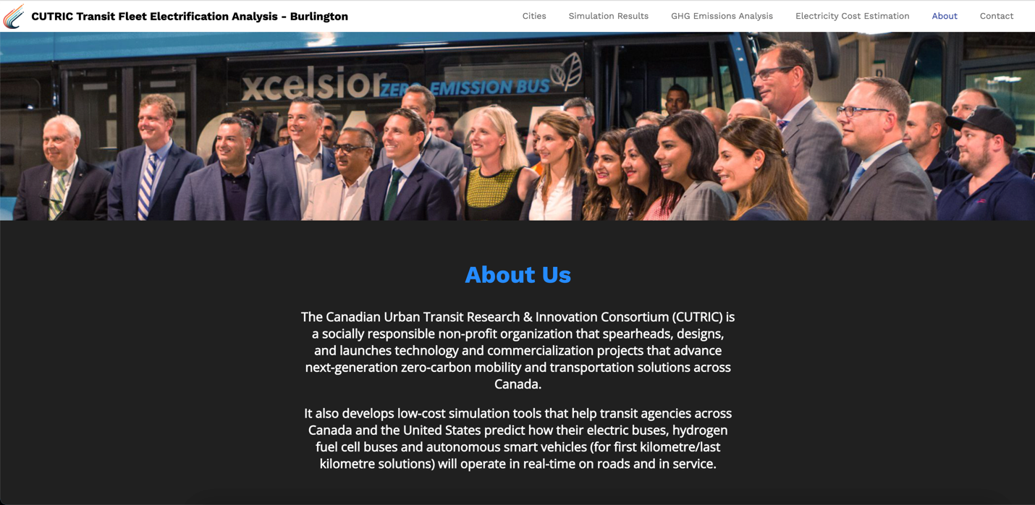

Figure - The About page

## 7. Contact Us

The user will be able to find all the contact information on the Contact Us page. The Email Us button can be customized to redirect to any email address. Again, we borrowed some information and an image from the CUTRIC website to indicate how it can be used as a template.

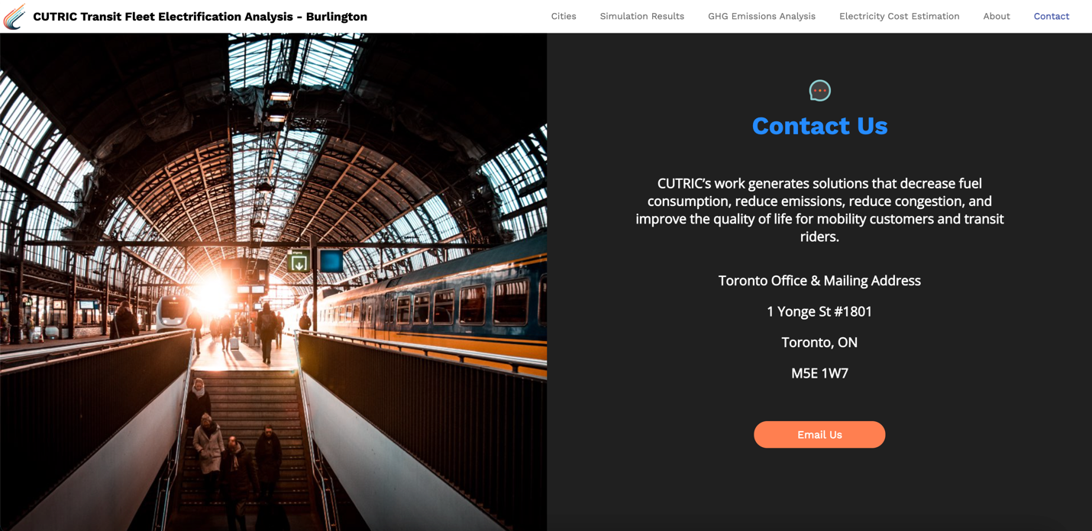

Figure - The Contact page

# Code Components

## Mapbox

To use Mapbox’s functions, the following libraries need to be imported first:

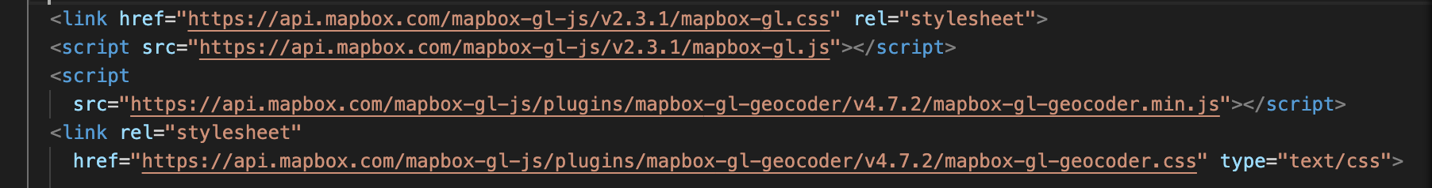

Figure - Mapbox libraries

Add maps to HTML divs with Mapbox access token and customized styles. To access the map style, use the following Mapbox GL username and password:

Mapbox username: graceyuan

Passwords: CUTRICburlington1!

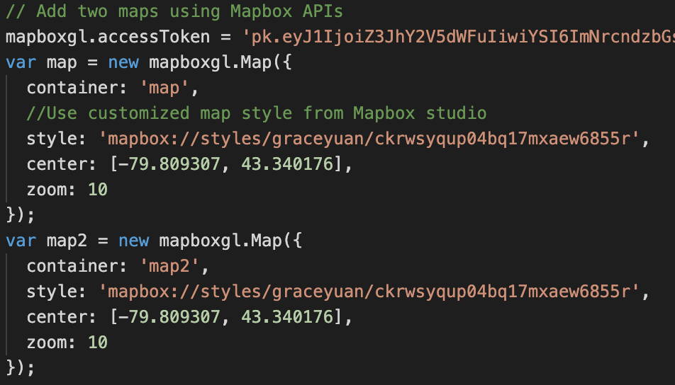

Figure - Add maps to HTML

All the map related visualization layers and functions need to go inside the following functions.

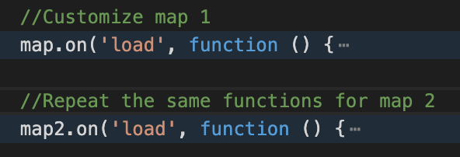

Figure - Add any map related functions under map.on ('load', function(){})

## D3.JS

Most D3.JS graphs displayed in the prototype are embedded through JavaScript runtime from Observable. We decided to go with this approach because 1) it is rather easy to use the existing D3.JS examples which are already hosted on Observable, 2) it lightens the weight of the code used in the local files.

To add a new graph or replace an existing graph on the page, replace the highlighted URL and the div id inside “Inspector(document.querySelector("______")”.

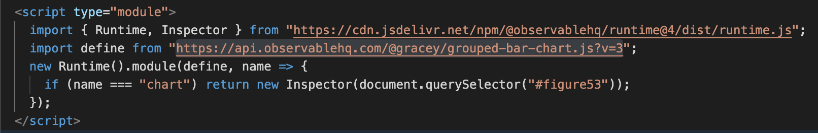

Figure - How to embed a graph from Observable

To edit or reuse a graph from Observable, go to the Observable link which can be found in the asset overview excel, and fork the notebook.



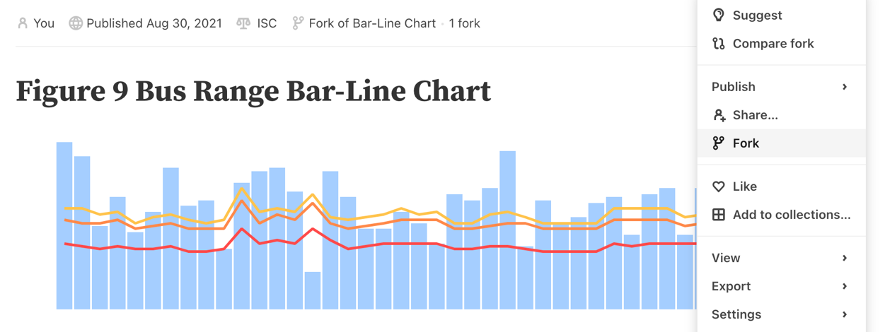

Figure - Fork the notebook to start editing

To replace the data set used in current graph, click on the paper click icon on the right and replace the csv file. For the graph to work, the data set needs to remain the same format as the csv that is currently being used.

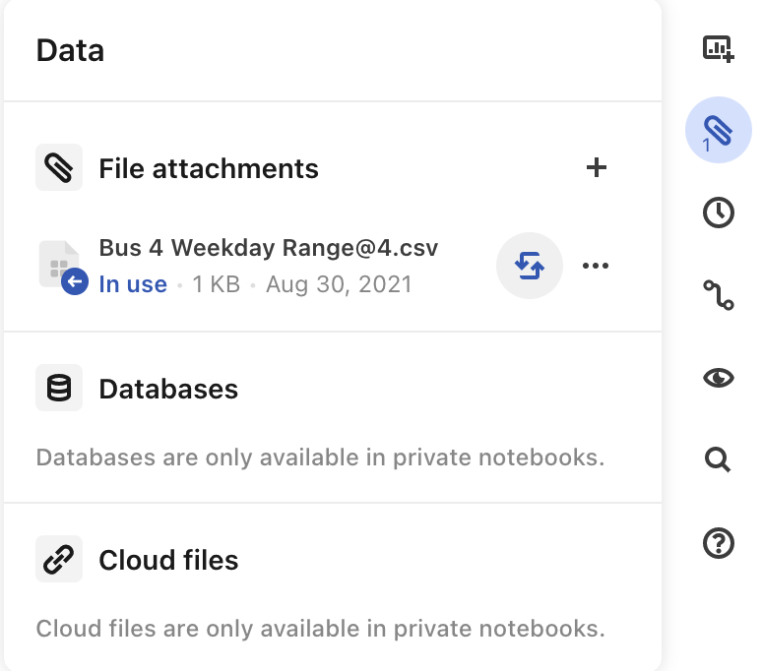

Figure - Replace the data

# Assets

We summarized an excel sheet with all the assets and library used in the code. The attached files can be found in the corresponding folders: green – “/data”; pink – “/image”. The blue items are external libraries or Mapbox tile sets.



Figure - Asset overview